**Git Assignments**

**A1 Solutions (Use Git as local VCS)**

1. Create a directory project_dir & cd to project_dir

$ mkdir project_dir

$ cd project_dir

1. Initialize git version database

$ git init

Initialized empty Git repository in C:/Users/sanke/project_dir/.git/

1. Create a new file index.html

$ touch index.html

1. Check the git status. You should find index.html as untracked file.

$ git status

On branch master

No commits yet

Untracked files:

(use "git add <file>..." to include in what will be committed)

index.html

nothing added to commit but untracked files present (use "git add" to track)

1. Stage the index.html file.

$ git add index.html

1. Commit index.html

$ git commit -m "Added index.html file"

[master (root-commit) 7e1680a] Added index.html file

1 file changed, 0 insertions(+), 0 deletions(-)

create mode 100644 index.html

1. Make few changes in index.html & create a new file info.txt file.

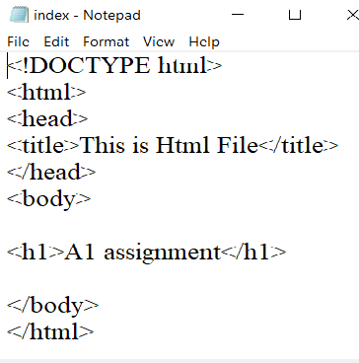

$ touch info.txt # to create new file info.txt

1. Check git status. You should find index.html & info.txt as untracked files.

* Here we find that index.html file as modified and info.txt as a untracked file

$ git status

On branch master

Changes not staged for commit:

(use "git add <file>..." to update what will be committed)

(use "git restore <file>..." to discard changes in working directory)

modified: index.html

Untracked files:

(use "git add <file>..." to include in what will be committed)

info.txt

no changes added to commit (use "git add" and/or "git commit -a")

1. Configure GIT to ignore all txt files

$ touch .gitignore

1. Again check the git status. You should find only index.html as untracked file.

* Here in index.html file showing as modified file and .gitignore file as untracked file

$ git status

On branch master

Changes not staged for commit:

(use "git add <file>..." to update what will be committed)

(use "git restore <file>..." to discard changes in working directory)

modified: index.html

Untracked files:

(use "git add <file>..." to include in what will be committed)

.gitignore

no changes added to commit (use "git add" and/or "git commit -a")

1. State & commit index.html

$ git add index.html

$ git commit -m "added paragraph"

[master eadabb8] added paragraph

1 file changed, 11 insertions(+)

1. Log all your comments so far.

$ git log

commit eadabb815af5ec17f6f8d4b15c94e3a063ceb2fa (HEAD -> master)

Author: sanketdalal05 <sanketdalal4122@gmail.com>

Date: Mon May 17 19:07:47 2021 +0530

added paragraph

commit 7e1680aac3c3751a6bb8c083a1066f3a754fc304

Author: sanketdalal05 <sanketdalal4122@gmail.com>

Date: Mon May 17 18:26:49 2021 +0530

Added index.html file

1. Make some changes in index.html

Adding h2 in index.html file

1. Revert the change made in the previous step using git command.

$ git checkout -- index.html

1. Again change Index.html

Adding italic to paragraph

1. Stage index.html

$ git add index.html

1. Revert back the last stage.

$ git rm --cached index.html

rm 'index.html'

1. Rename 'add command to 'my-add.

$ git config --global alias.my-add add

1. Using my-add command Stage index.html again & commit the changes.

$ git my-add index.html

$ git commit -m "added italic paragraph"

[master f701e84] added italic paragraph

1 file changed, 1 insertion(+)

1. Revert the last commit.

$ git rebase -i HEAD~1

Successfully rebased and updated refs/heads/master.

**A2 Assignments Solution (Git branching )**

Done with a backup of files and projects.

$ mkdir Assignments

$ cd Assignments

$ git init

$ touch README.txt

$ git add README.txt

$ git commit -m "added assignment folder"

[master (root-commit) 0a76e80] added assignment folder

1 file changed, 1 insertion(+)

create mode 100644 README.txt

$ git branch html-assignments

$ git checkout html-assignments

Switched to branch 'html-assignments'

Copy html assignments to assignment folder

$ git add index.html

$ git commit -m "added index.html"

[html-assignments 47f05d0] added index.html

1 file changed, 11 insertions(+)

create mode 100644 index.html

Making minor changes in html assign branch

$ git add index.html

$ git commit -m "added paragraph"

[html-assignments 1c45830] added paragraph

1 file changed, 1 insertion(+)

$ git checkout master

Switched to branch 'master'

$ git add README.txt

$ git commit -m "html assig"

[master ba4cd5c] html assig

1 file changed, 2 insertions(+), 1 deletion(-)

$ git checkout html-assignments

Switched to branch 'html-assignments'

Adding heading 2

$ git add index.html

$ git commit -m "added h2 heading"

[html-assignments 720502f] added h2 heading

1 file changed, 1 insertion(+)

$ git checkout master

Switched to branch 'master'

$ git merge master html-assignments

Merge made by the 'recursive' strategy.

index.html | 13 +++++++++++++

1 file changed, 13 insertions(+)

create mode 100644 index.html

$ git branch -d html-assignments

Deleted branch html-assignments (was 720502f).

**Css assignments:**

$ git branch css-assignments

$ git checkout css-assignments

Switched to branch 'css-assignments'

css file into assignment folder

$ git add style.css

$ git commit -m "css file added "

[css-assignments c9f71b6] css file added

1 file changed, 27 insertions(+)

create mode 100644 style.css

Minor changes in README.txt

$ git add README.txt

$ git commit -m "first line added"

[css-assignments 879e1dc] first line added

1 file changed, 1 insertion(+), 1 deletion(-)

$ git checkout master

Switched to branch 'master'

$ git add README.txt

$ git commit -m "minor changes in third line "

[master 297c599] minor changes in third line

1 file changed, 2 insertions(+), 1 deletion(-)

$ git checkout css-assignments

Switched to branch 'css-assignments'

Added fourth line in

$ git add README.txt

$ git commit -m "added fourth line README.txt file"

[css-assignments 3743a0e] added fourth line README.txt file

1 file changed, 4 insertions(+), 2 deletions(-)

$ git checkout master

Switched to branch 'master'

$ git merge master css-assignments

$ git commit -a

[master ef01320] Merge branch 'css-assignments'

$ git branch -d css-assignments

Deleted branch css-assignments (was 3743a0e).

**Section -3 Javasscript assignments**

git branch js-assign

$ git checkout js-assign

Switched to branch 'js-assign'

Hello,js copy to assignment folder

$ git add hello.js

$ git commit -m "hello.js file added"

[js-assign 21106c0] hello.js file added

1 file changed, 16 insertions(+)

create mode 100644 hello.js

Makes minor changes on readme.txt line 1 belong js branch

$ git add README.txt

$ git commit -m "first line changes on readme.txt belong to js branch"

[js-assign 85e59d9] first line changes on readme.txt belong to js branch

1 file changed, 1 insertion(+), 1 deletion(-)

$ git checkout master

Switched to branch 'master'

Update first line belong to master

$ git add README.txt

$ git commit -m "first line minor changes belong to master branch"

[master 8494876] first line minor changes belong to master branch

1 file changed, 1 insertion(+), 1 deletion(-)

$ git checkout js-assign

Switched to branch 'js-assign'

$ git add .

$ git commit -m "my name updated in hello world js file"

[js-assign 6ea1d6c] my name updated in hello world js file

1 file changed, 2 insertions(+), 2 deletions(-)

$ git checkout master

Switched to branch 'master'

$ git merge master js-assign

$ git add .

$ git commit -m "no conflicts"

[master 8027cd1] no conflicts

$ git branch --merged

js-assign

* master

$ git branch -d js-assign

Deleted branch js-assign (was 6ea1d6c).

**A3 Git Remoting**

**(Pushing assignments to remote repo)**

I have Created github account



I have already logged in github account

Done with creating repo as fresherbarch-oct16

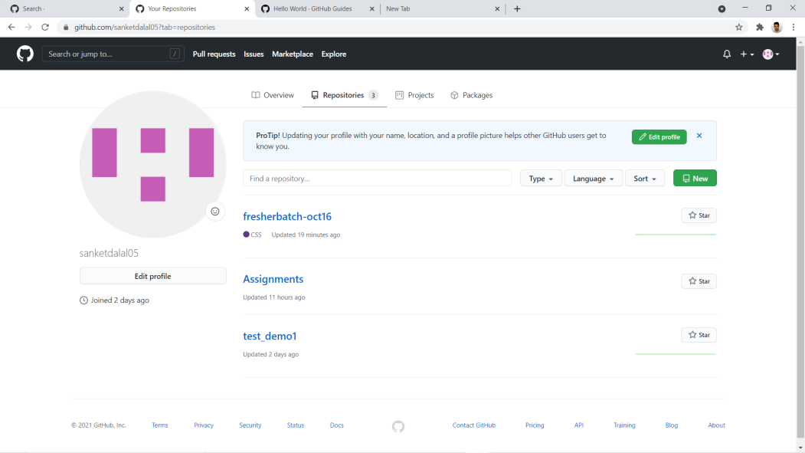



I pushed sample file to this remote repo which is under assignment directory

$ git remote add origin https://github.com/sanketdalal05/fresherbatch-oct16.git

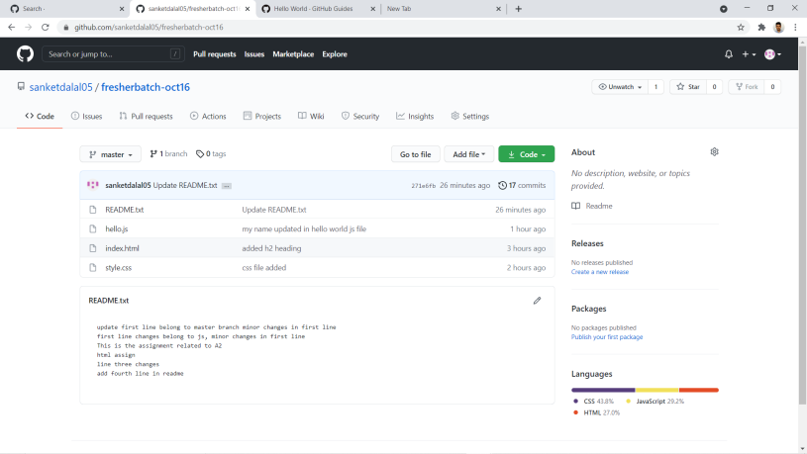

**A4 section-4 (pushing source code to remote repo using eclipse Git plugin)**

1. 2. 3. 4.

First I have created sampleproj directory on remote then on eclipse created

Sampleproject1 which is a java project.

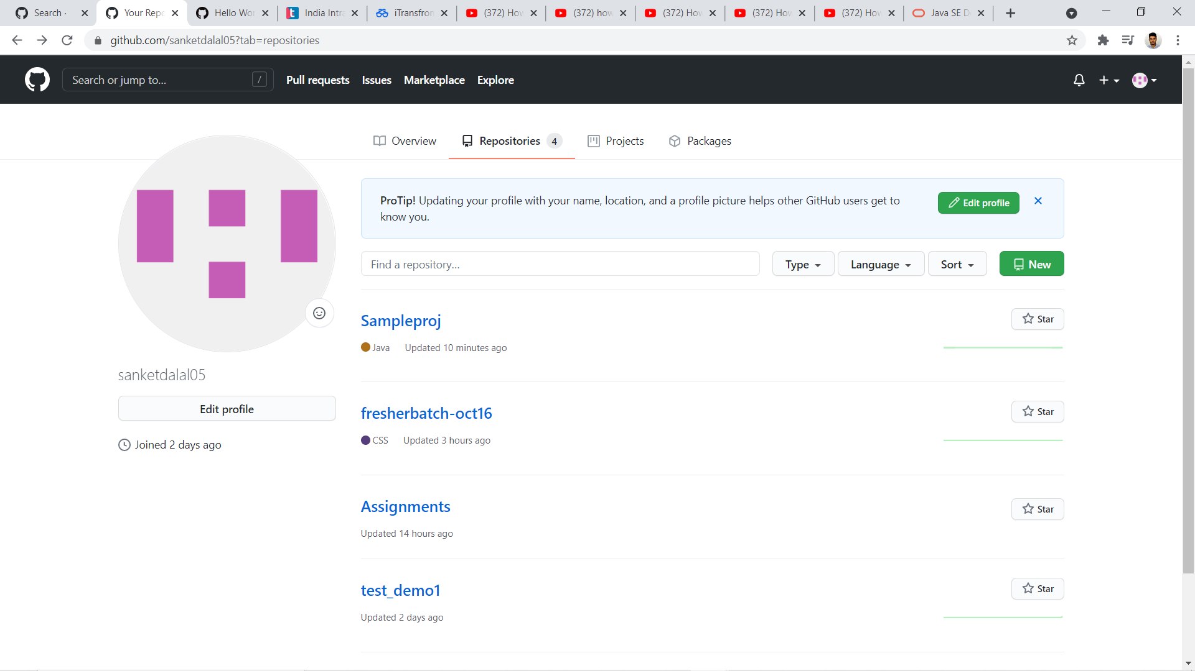

Collaborate other team members by using go to project right click go to team and shared project by configuring git repository. Selecting repo path which is on github

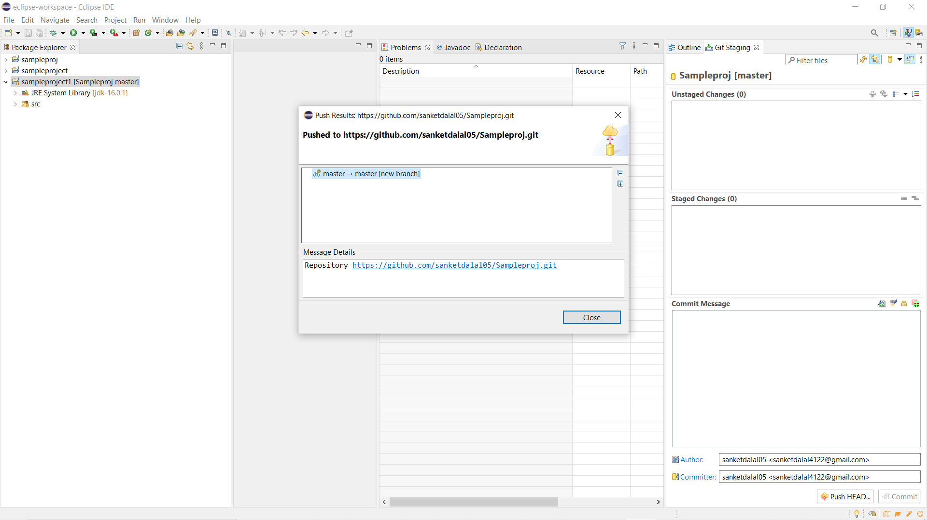

Finally project file commit and pushed on to remote (github)



